Any Parish Council Catholic Women’s League
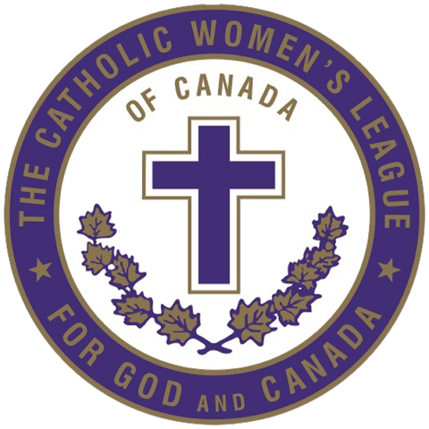
Fashion Afternoon!

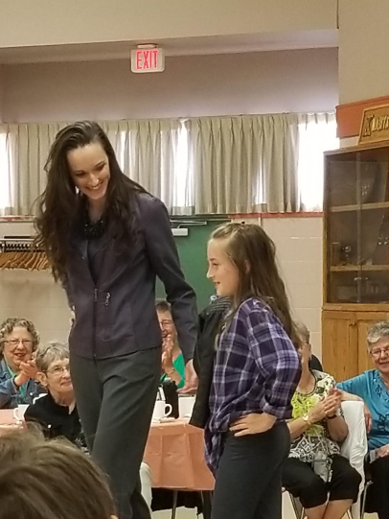

Saturday, May 7, 2023
1:00 p.m. – 3:00 p.m.
Any Parish Hall
Today’s Schedule

- Mother and Daughter collection
- Mothers on the Go collection
- Grandmother Chic collection
- Professional Mothers collection
- Juniors Fun in the Sun collection
- Date Night Collections

Special Thanks go out to…

- Any Parish – for the use of the Hall
- Momma Mary’s Boutique – for supplying the clothes for the show
- Any Parish Youth Group – for helping model the juniors’ collection
- Mrs. Helen Grice – for organizing the event!
- Mom and Pops Cafe – for catering the reception after the show
- The members – for organizing and modeling these clothes!

